# **Section 6.3 Formal Reasoning**

**Making sense of the Proof Rules**

How to read the rules in the sheet: If you know the things on the top, then you can conclude that the bottom of the line is true.

* Modus Ponens (MP): For example, if you know A is true and A implies B is true, it’s reasonable to conclude B is true.
* Conjunction (Conj): If you know A and B are true, then it’s reasonable to conclude that the conjunction of A and B is true.
* Addition (Add): If you know A is true, then A or B and B or A is true (this is because for an OR, only one must be true for the whole statement to be true).

You can prove everything with truth tables (except for indirect and conditional proofs). Each other rule is a tautology, and really, many of them are WFFs.

**Definitions**

An axiom is something you know to be true.

A proof is a finite sequence WFFs such that each WFF is either an axiom or can be inferred from the previous WFFs in the sequence.

The last WFF in a proof is called a theorem.

**Proof Notation**

* Put each WFF on a numbered line along with a reason.
* Use a letter P for a premise.
* Follow the proof with QED.

## **Examples**

**1:** Prove D given the following premises: A ∨ C ⟶ D, ¬ B, A ∨ B

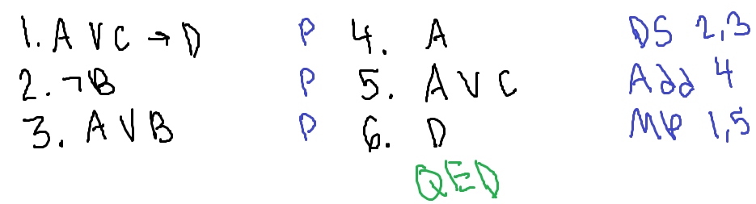

Make sure to include the lines that are used for each rule. Here, you look for the things that match the top based on the things you know that are true.

**2:** Prove (A ∨ B) ∧ (C ∨ D) given the premise A ∧ D.

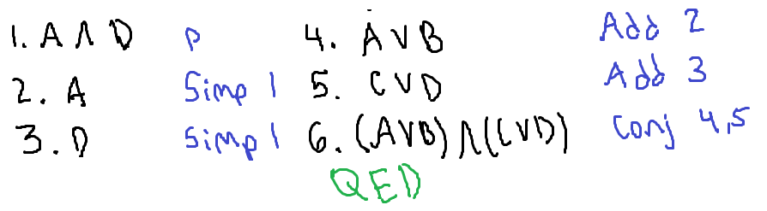

**3:** Prove D ∧ F given the premise (E ∧ F) ∧ (C ∨ D) ∧ ¬ C.

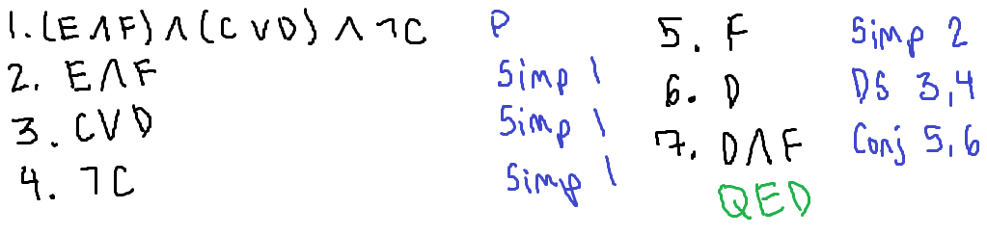

**4:** Prove the same thing as Example 3 with the same proof as Example 3.

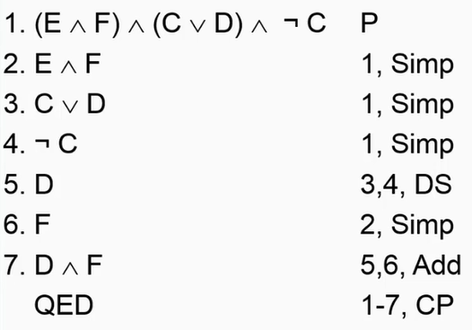

The last line is the *actual* line of proof. There is no line number.

The line we wanted to stuff:



* The QED was used. The textbook author says, “We omit the writing of the result because it can be quite lengthy in some cases.
* If you use CP as the last line of your proof, you just indent and write QED, not the long implication. You also need to cite ALL the lines since the premise. You also can’t use CP or IP anywhere else above (for now).

**5:** Another CP example with Example 2.

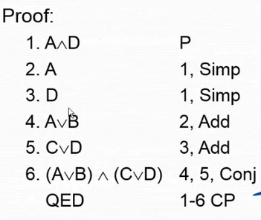

Notice the same things as the previous example.

**6:** Prove that ((A ∨ C ⟶ D) ∧ ¬ B ∧ (A ∨ B)) ⟶ D is a tautology.

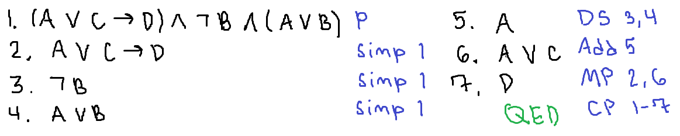

The book skips the premise line. The book splits up the “if parts” of the conditional that are and-ed together as a premise.

**7:** Prove that the following WFF is a tautology: (A ∨ B ⟶ C ∧ D) ∧ A ∧ (C ⟶ E) ⟶ D ∧ E.

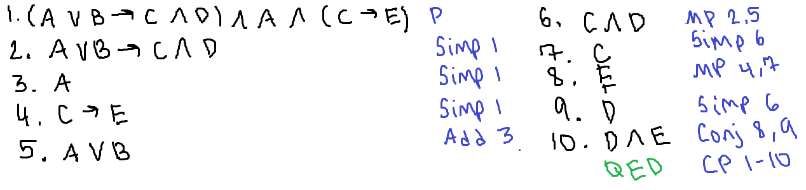

## **IP Trick: Proving that a WFF is a tautology**

* Start with ¬ WFF as a premise
* Prove False without using CP or IP
* Now, use IP to conclude WFF

**8:** Prove that ¬ (A ∧ ¬ A) is a tautology.

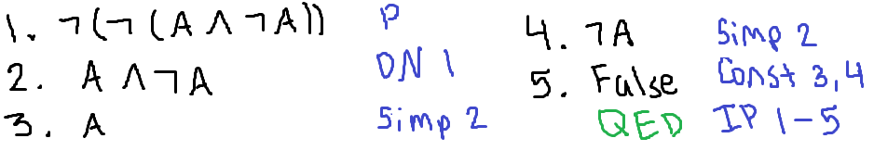

When you use CP or IP for a proof, the premise is said to be “discharged” and you use all the lines starting with the premise as your reason.

Why? It’s about subproofs.

## **Subproofs**

A subproof is a proof that is part of another proof. It starts with a premise and ends by applying CP or IP to the result.

After you’ve done so:

* The premise is “discharged”
* The WFFs in the derivation become “inactive”
* Think “local variable” and goes out of scope when I leave the subproof”

Notation:

* Indent the statements of the subproof
* Write down the result of CP or IP without indentation
* Think “code block” with good indentation

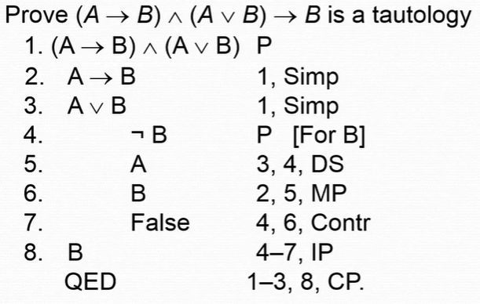

Commentary for the right example:

* For line 4, you put [For B] because you are trying to prove B
* The scope of the subproof is not available to the CP reasoning, so that’s why you skip those lines
* The line after an indent is the out-dent, and the only line outside the indentation that can use the lines within it

**Rules for Subproofs**

* You only have a subproof if you’re planning on exiting it with CP or IP
* When you start a subproof, you can have just ONE premise, and you need to write what your CP or IP “exit goal” is (ex. [For B]).

**Rules for CP and IP**

* CP and IP can only be used as the last line of a proof or a line right after a subproof
* If you use them to exit a subproof, then everything in the subproof is “out of scope” for the rest of your proof

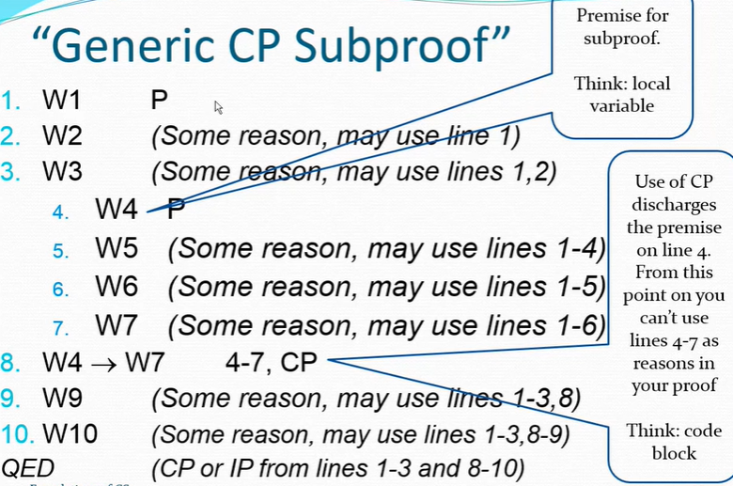

**9:** Prove the converse of (A ∨ B) ⟶ (¬ B ⟶ A). AKA, prove (¬ B ⟶ A) ⟶ (A ∨ B). (*You’re not expected to complete this complex of a proof, but understand it so you can do subproofs.*)

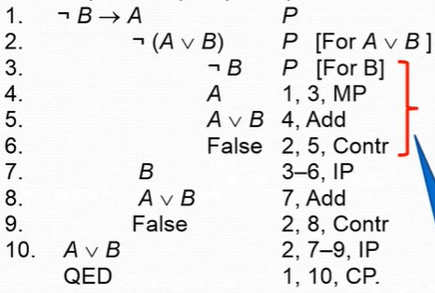

## **Making Propositional Logic Useful**

Turn English statements into WFFs.

Example: I eat spinach (*S*) or ice cream (*I*). If I study logic (*L*), then I will pass the exam (*P*). If I eat ice cream, then I will study logic. If I eat spinach, then I will play golf (*G*). I failed the exam. Therefore, I played golf.

Premises: *S* ∨ *I*, *L* ⟶ *P*, *I* ⟶ *L*, *S* ⟶ *G*, ¬ *P*

Conclusion: *G*

To prove this, it’s best to use the derived proof rules:

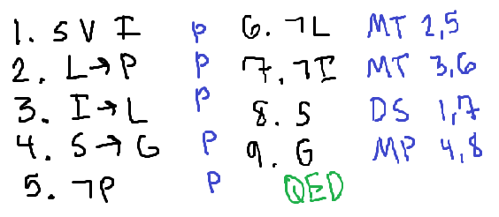

You can also prove the derived proof rules using truth tables.